MINDARIE REGIONAL COUNCIL

Request for Tender NO: 13-166
ENVIRONMENTAL MONITORING SERVICES

The Mindarie Regional Council are seeking the services of a suitably experienced and qualified consultant to provide essential environmental monitoring services at the Tamala Park Waste Management Facility. This will involve, but not limited to the monitoring and reporting of key compliance requirements pertaining to a waste management facility.

RFT documents will be available from Thursday 09 May 2024. Tender submissions must be uploaded through the MRC website or portal.tenderlink.com/mindarie. For technical assistance, please call illion TenderLink's customer support on 1800 233 533 or email support@tenderlink.com.

Respondent’s submissions can contain up to 25 files, (no more than 2GB in total), and be uploaded no later than the deadline of 12pm WST, Thursday 30 May 2024.

If the Tenderer canvasses any of the Principal’s Councillors or Officers with a view to influencing the acceptance of any Tender, the Principal may invalidate the Tender.

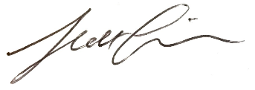

Scott Cairns
Chief Executive Officer

